Reporting en evaluatie EWRC workshop 10 oktober 2023, Brussel. JDE 63

10WS2324 Plants: the solution for a sustainable and healthy future of Europe

REPORT tot the EC and others:

Summary of key messages

Enhancing Agricultural Innovation and Sustainability for a Thriving Planet:
Agriculture stands at the crossroads of innovation and business, serving as a linchpin for the future of our planet. Plants are the drivers for sustainable and healthy recourses for food, materials, energy, etcetera.
Yet, the journey to scale up its potential remains imperative. Notably, the plant production sector is predominantly composed of Small and Medium-sized Enterprises (SMEs). To navigate the ever-evolving landscape of innovation, growth, and globalization, collaboration becomes an indispensable driver.
A harmonious consortium, bringing together an array of complementary skills, partners, regions (ERIAFF), clusters (Plant Inter Cluster), and an ETP (Plants 4 the Future), is poised to engage in meaningful discourse on cooperation and networking.

The Significance of Agriculture in Europe's Geopolitical Landscape:
The agriculture sector in Europe serves as a pivotal lifeline with far-reaching geopolitical implications. The formidable challenges of climate change, reduced pesticide usage, and the sustainable management of resources exert profound influence, particularly on the plant industry.
In response to these barriers, numerous plant clusters have united their efforts to foster connections among innovative projects. As we unite across Europe, we demonstrate the paramount importance of sustainable and efficient plant production to address:
• The dual mission of producing high-quality food and ensuring food security.
• The poignant fact is that 36 million Europeans (comprising 8.3% of the population) grapple with the scarcity of a warm meal every two days.
• The imminent global challenge of providing nourishment to an estimated 9.8 billion people by 2050.

Urging a Wider Application of this Approach within the Farm to Fork (F2F) Strategy:
The European Plant Science Organisation strongly advocates for the incorporation of this approach within the broader framework of the Farm to Fork strategy, signifying the European Commission's commitment to:
• Ensuring that the most sustainable food sources also become the most affordable, thereby prioritizing nutritious food.
• Pioneering an ambitious sustainability chapter within all bilateral trade agreements, extending it as deemed appropriate to the Food and Nutrition Security (FNS) domain.
• Striving for a higher uptake of sustainability standards in consumer food information, which FNS standards can complement.
It's heartening to note that these messages resonated with our audience, comprising 68% from local and regional governments and 11% from the European Commission or Parliament. Together, we are paving the way for a more sustainable and prosperous agricultural future.

Quotes from the speakers:

Bouke Arends:
Graag iets over Feeding and Greening Megacities
De conclusie heb ik nl. al hierboven verwerkt

Daniel Buda:
Fostering stronger agricultural cooperation within Europe is crucial for sustainability, food security, and well-being.

Karin Metzlaff:
“Food consumption patterns are currently unsustainable from health and environmental point of view (too high energy, red meat, sugars, salt, fats; too low whole-grain cereals, fruit and vegetables). Reverse rise of overweight and obesity rates by 2030. Moving to more plant-based diets with less and processed meat and with more fruits and vegetables will reduce risks of life-threatening diseases and environmental impact of the food system.”

Audience: 48 persons:
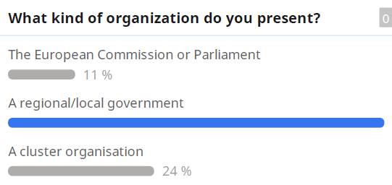

35%

